1.Introduction and background

* 1. **What is senior project?**

In CAMT (college of Art, Media and Technology), there is a significant event for every student. This is senior project. Senior project is one project which usually be done during the forth year of senior students. For undergraduates, senior project is the most important project in their college life for senior project stands for what they have learned during the college study. What’s more, they can not graduate unless they success in senior project.

* 1. **How the senior project manages?**
  2. **Goal of project**
* **Purpose:**

Senior project management system is an application which aims at helping the people involve with senior project to do their jobs easier.

* **Advantage:**

With senior project management system:

1. Senior project manager will be able to manage all the issues of senor project easier with less efforts
2. Adviser will be able to manage the works with his/her teams and the presentation works easier.
3. Students will be able to manage their own works easier.

## ***2.Leterature review***

* 1. **Business Review**

**I**n principle, students have to complete senior project during their forth years in group of tow people or alone. At first, students who have the qualification and the whish to do senior project will **register** for doing this project. Then students have to group themselves into one group of one or two people. After the first meeting for elucidating the basic principles of senior project, every group has to find one adviser who will give them suggestion during whole processes of senior project. After being taken by one adviser, students would be able to start the first step—**proposal**. During the first step, students will prepare the document of proposal as well as the proposal presentations which will be evaluated by three lecturers include the group’s adviser. Only the group who pass the proposal presentation could continue to do next step which is design part. The groups who can not pass this at first time will get second chance which can not fail otherwise they have to redo the senior project next year. In additional, students cannot ***fail three times*** (get more than 3 times ‘F’) in total. In the design part, students have to prepare both *document* and *presentation* as proposal part. Just like the rules in proposal part, only successors will be able to develop the software, which is the last procedure. After passing these **three processes**, students pass the senior project. Within the whole way, advisers will suggest the group they have taken and **evaluate** the works of some groups. If the project is pass evaluation from advisors, it can go to show Pro phase. **Show Pro** is publish your project to a kinds of people, like junior student, some IT company etc. after the show Pro, the **final presentation** will decide your project is pass or not finally. Lastly, the **English check**. When you pass the final presentation and English, you get grade of successful of senior project. Moreover, there is one manager who manages all events of senior project to guarantee everything goes well.

* + 1. **Senior Project Activity Flow**

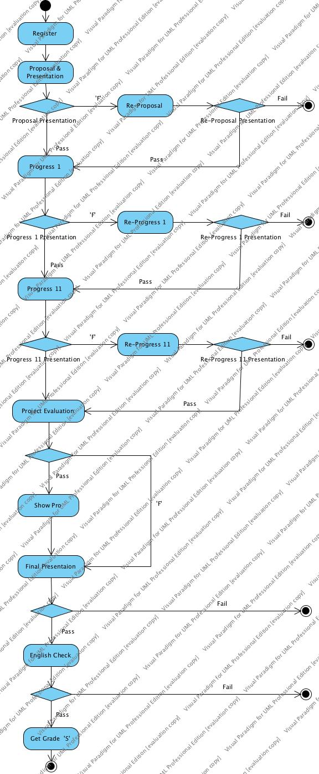

* + 1. **Business Problems of Three Phase**

**T**here are 11 major activities in total in senior project, some business events occur many times in different activities. Some phase also have many same activities. Collecting those common parts, the process of senior project can be summarized to there phase. Preparing phase represent the register, remind activities be separated to developing phase and Grading phase.

* Preparing phase

1. Student only have paper document refer to past senior project. Each document of past senior projects only one piece. Hunger, un-order document is hard to borrow and search information. It’s spends large time that can’t find your real want.
2. Student don’t know each advisor status of accepted teams, it result that student cant be accepted by advisor they expect.
3. Students hard to meet advisor. Advisors have large business.
4. Manager needs group-sending many messages, but the operation is not so simple.
5. Manager statistics each advisor and their team by hand, it’s spend much time and easy have mistakes.

* Developing phase

1. Advisor hard to manage all own team.
2. It’s not easy to manage all versions of teams work.
3. There is no single way to unified manage all own teams.
4. Advisor need team status or task process warming.
5. Students not have a good time management, and can’t check new schedule on time I when the senior project have change.

* Grading phase

1. Manager assigns venue of advisors and teams for each presentation is very complex work.
2. Manager receives and calculates each team score form each advisor and records team status by hand.
3. Advisor need grade team score and submit electronic version result to manager.
   * 1. **Features List**

Target User:

Manager

Adviser

Student

* Manager

1. Manage the schedule for whole process.
2. Inform messages by group with junior students, register students, advisers etc.
3. Generate presentation detail with venue, time.
4. View presentation grade result.
5. Inform each team status, statistic ‘F’ times.

* Adviser

1. Manage appointments.
2. Take a team.
3. Manager the schedule for own teams.
4. Grade each presentation with own device.
5. View own teams status.

* Student

1. Register senior project course.
2. View status of advisor in real-time in register time.
3. Search, view advisors, makes an appointment with the advisor they chose.
4. Manage own team schedule.
5. Inform team status with fail times.

* Database
  1. Store all successful teams work of senior project.
  2. Category senior project by type, sort by score, year, advisor.
  3. Provide search previse senior project.

**2.2Technology Review**





# ***3.Quality Standard***

1. **ISO29110 for Very Small Entity (VSE)**

ISO29110 is a guide applies to a Very Small Entity (VSE), enterprise, organization, department or project up to 25 people, dedicated to software development. The Guide provides Project Management and Software Implementation processes which integrate practices based on the selection of ISO/IEC 12207- Systems and Software Engineering —Software Life Cycle Processes and ISO/IEC 15289 Software Engineering – Software Life Cycle Process – guidelines for the content of software life cycle process information products (documentation) standards elements.

1. **Project Management process**

The purpose of the Project Management process is to establish and carry out in a systematic way the tasks of the software implementation project, which allows complying with the project’s objectives in the expected quality, time and cost.

Selected process

3.1.1.1 Project Planning Process

3.1.1.2 Project Plan Execution Process

3.1.1.3 Project Assessment and Control Process 3.1.1.4 Project Closer Process

1. **Software Implementation process**

The purpose of the Software Implementation process is the systematic performance of the analysis, design, construction, integration and tests activities for new or modified software products according to the specified requirements.

1. **Selected process**

3.1.2.1 Software Implementation Initiation Process 3.1.2.2 Software Requirements Analysis Process 3.1.2.3 Software Architectural Design Process 3.1.2.4 Software Construction Process

3.1.2.5 Software Integration and Test Process

# 4.Project Plan

4.1 Deliverable

* Proposal
* Project plan
* Software requirement specification
* Software design document
* Testing document
* Traceability record

4.2Limits

// don’t sure about how many feature we can implement. Talk.